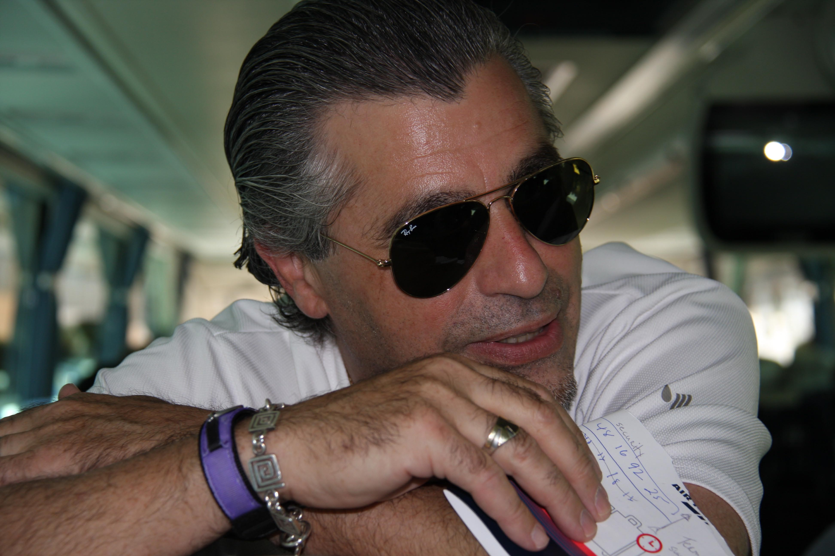
A Street Encounter
by Rob Styler and presented at the LCJE conference in Phoenix, 2009

There was not much going on, not much at all
God came into my life, He came with a call

He said, “There is something I want you to doish
Share the Messiah with my people, their Jewish”

That’s nice but I was Catholic you know
He said, “When I tell you something just go”

I went to the streets looked people in the eye
And wouldn’t you know I’d run into a rabbi

He said, “You’re so smart there’s so much you knewish
On Top of it all you aren’t even Jewish

I bet you don’t know Hebrew or the Talmud too
And you’re telling me about Messiah, me a Jew!

Rabbi listen just listen- here’s the plan
It comes from Moses – isn’t he your man

Even though he was angry I tried to be nice
I mentioned Leviticus and the need for a sacrifice

The rabbi listened and gave me a frown,
Hey there bubbeleh, the temple’s torn done

We have no high priest and there is no temple mount
But I do my mitzvoth making all of them count

I daven several times a day and I lay tephillin
I can help you convert, even you, if you’re willin

So I said Rabbi please don’t be mad
But what you’re telling me makes me sad

Rabbi let me say one thing, just one thing I’ll doah
I have good news – the end of the Law is Yeshua

Please just hear me out, this is no joke
He’s the One of whom the prophets spoke

He fulfilled the Law of Moses for you and for me
If you will place your trust in Him and you will be free

Then very quickly he turned and went on his way
I felt bad but I knew he’d heard the truth that day

I watched sadly as he made his way down the street
I said a quick prayer his Messiah he’d meet

Rob Styler

